The Blackall Cultural Association Inc.

www.blackallcultural.org.au

**Annual Art and Photography Exhibition 2022**

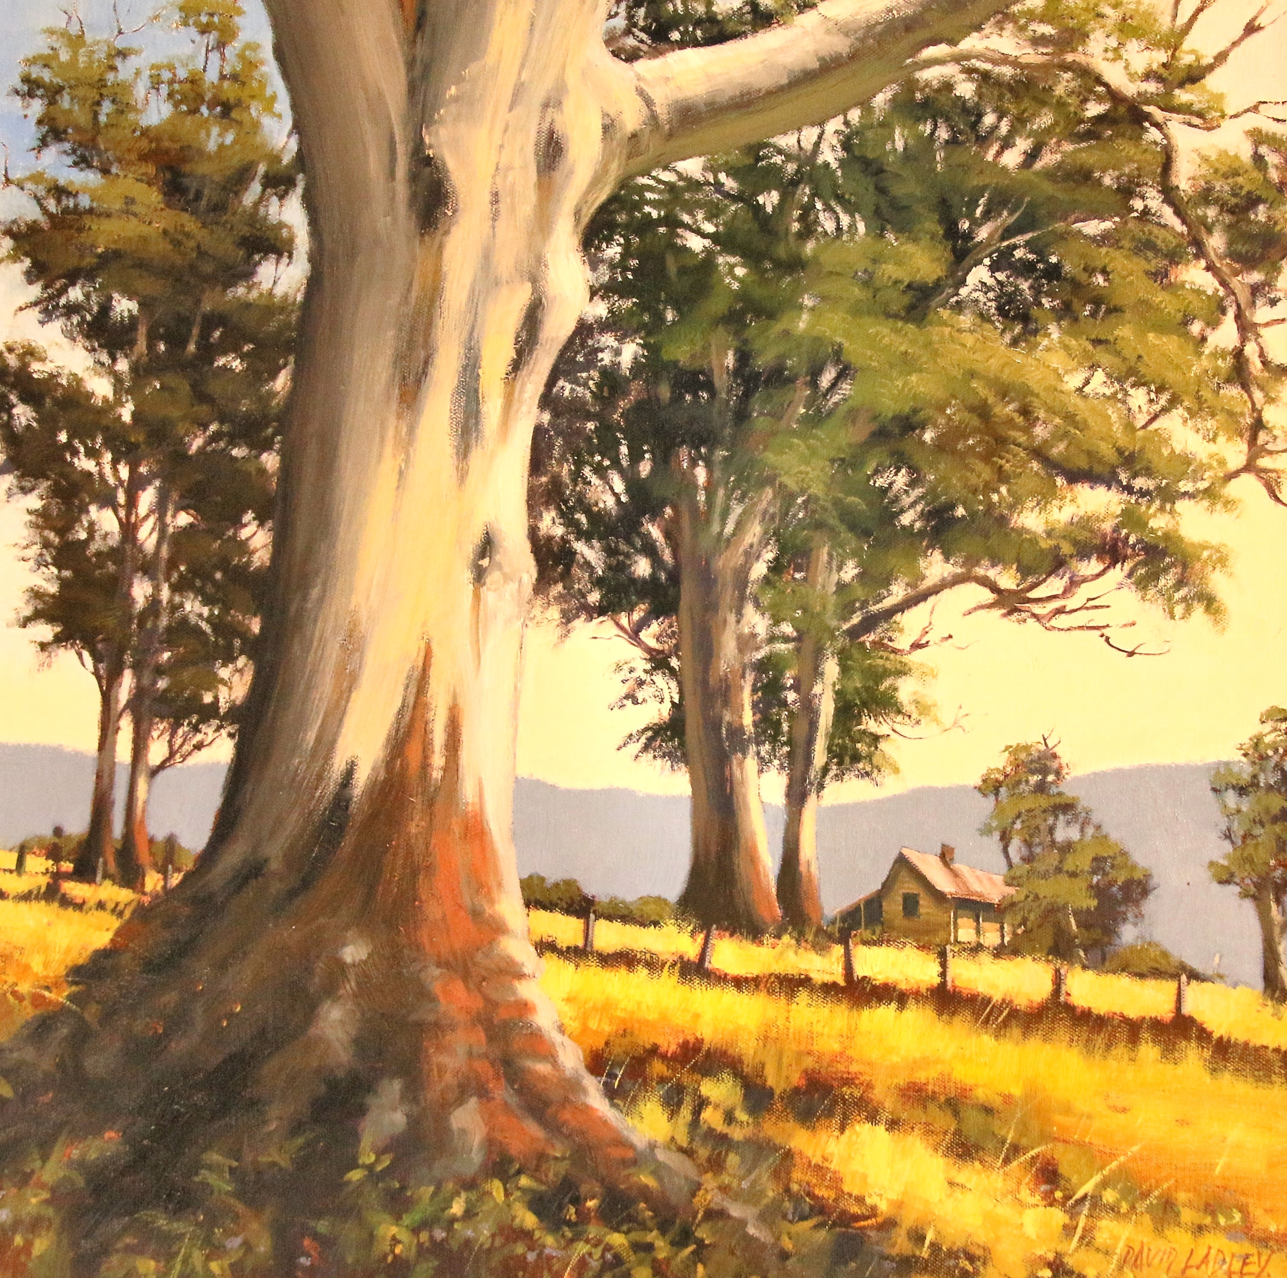

**Friday 14 Oct 2022**

**From 6.00pm**

**Blackall Cultural Centre, cnr of Shamrock and Hawthorn Street, Blackall**

**ENTRY FEE $20**

**Includes meal**

**TOTAL PRIZE MONEY $9000**





